

DEPARTMENT OF COMPUTER SCIENCE AND ENGINEERING

COURSE CODE: 22CS702

INTERNET OF EVERYTHING LABORATORY


Continuous Assessments Record

Submitted by

NAME
REGISTER NO
YEAR & SEMESTER
DEPARTMENT | Computer Science and Engineering
SECTION
ACADEMIC YEAR | 2025-2026 (ODD Semester)


Department of Computer Science and Engineering

22CS702 – INTERNET OF EVERYTHING LABORATORY

Submitted by

Register No.:
Name :

Degree : Branch :

BONAFIDE CERTIFICATE

This is to certify that this is a Bonafide record work by Mr./Ms…………………………………………… Register No: …………………………. during the academic year 2025 – 2026.

Faculty In-charge

Submitted for the Autonomous Practical Examination held on

………..........

INTERNAL EXAMINER EXTERNAL EXAMINER

Department of CSE | IV year /VII Semester | 22CS702 INTERNET OF EVERYTHING LAB

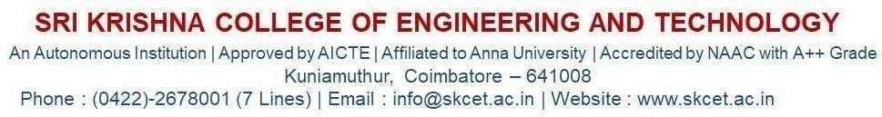

DEPARTMENT OF COMPUTER SCIENCE AND ENGINEERING (Batch 2022-2026)

VISION OF THE INSTITUTION

- To Produce Globally Competitive Engineers with High Ethical Values and Social Responsibilities.


MISSION OF THE INSTITUTION

- To impart the highest quality state-of-the-art technical education by providing impetus to innovation, research, and development and empowering students with entrepreneurship skills.
- To instill ethical values, imbibe a sense of social responsibility, and strive for societal well-being.
- To identify the needs of society and offer sustainable solutions through outreach programs.

DEPARTMENT OF COMPUTER SCIENCE AND ENGINEERING VISION OF THE DEPARTMENT

- To prepare professionals with high technical, research and entrepreneurial skills as well as ethical values who will contribute to the computational world.

MISSION OF THE DEPARTMENT

- To develop human resources with the ability and attitude to adapt to emerging technological changes through academic and research-oriented events.
- To identify current socio, economic problems of national and international significance and provide solutions through competency centers.
- To impart ethics, social responsibilities and necessary professional, entrepreneurial and leadership skills through student lead activities

I. PROGRAMME EDUCATIONAL OBJECTIVES (PEOs)
To enable graduates to
PEO 1 | Be successful in their career in industries associated with Computer Science and Engineering.
PEO 2 | Comprehend, analyze, design, and create novel products and solutions for the real- life problems.
PEO 3 | Possess professional and ethical attitude, effective communication skills, team working skills, multi-disciplinary approach, and an ability to relate engineering issues to broader social context.
PEO 4 | Exhibit leadership qualities and progress through life-long learning.

II. PROGRAMME OUTCOMES (POs)
PO 1 | Engineering Knowledge: Apply knowledge of mathematics, natural science, computing, engineering fundamentals and an engineering specialization as specified  in WK1 to WK4 respectively to develop to the solution of complex engineering problems.
PO 2 | Problem Analysis: Identify, formulate, review research literature and analyze  complex engineering problems reaching substantiated conclusions with consideration for sustainable development.
PO 3 | Design/Development of Solutions: Design creative solutions for complex engineering problems and design/develop systems/components/processes to meet identified needs with consideration for the public health and safety, whole-life cost,  net zero carbon, culture, society and environment as required.
PO 4 | Conduct Investigations of Complex Problems: Conduct investigations of complex engineering problems using research-based knowledge including design of  experiments, modelling, analysis & interpretation of data to provide valid conclusions.
PO 5 | Engineering Tool Usage: Create, select and apply appropriate techniques, resources and modern engineering & IT tools, including prediction and modelling  recognizing their limitations to solve complex engineering problems.
PO 6 | The Engineer and The World: Analyze and evaluate societal and environmental aspects while solving complex engineering problems for its impact on sustainability  with reference to economy, health, safety, legal framework, culture and environment.
PO 7 | Ethics: Apply ethical principles and commit to professional ethics, human values, diversity and inclusion; adhere to national & international laws.
PO 8 | Individual and Collaborative Team work: Function effectively as an individual, and as a member or leader in diverse/multi-disciplinary teams.
PO 9 | Communication: Communicate effectively and inclusively within the engineering community and society at large, such as being able to comprehend and write effective reports and design documentation, make effective presentations  considering cultural, language, and learning differences
PO 10 | Project Management and Finance: Apply knowledge and understanding of engineering management principles and economic decision-making and apply these  to one’s own work, as a member and leader in a team, and to manage projects and in multidisciplinary environments.
PO 11 | Life-Long Learning: Recognize the need for, and have the preparation and ability  for i) independent and life-long learning ii) adaptability to new and emerging technologies and iii) critical thinking in the broadest context of technological change.

Knowledge and Attitude Profile (WK)
WK1 | A systematic, theory-based understanding of the natural sciences applicable to the discipline and awareness of relevant social sciences.
WK2 | Conceptually-based mathematics, numerical analysis, data analysis, statistics and formal aspects of computer and information science to support detailed analysis and modelling applicable to the discipline.
WK3 | A systematic, theory-based formulation of engineering fundamentals required in the engineering discipline.
WK4 | Engineering specialist knowledge that provides theoretical frameworks and bodies of knowledge for the accepted practice areas in the engineering discipline; much is at the forefront of the discipline.
WK5 | Knowledge, including efficient resource use, environmental impacts, whole-life cost, re-use of resources, net zero carbon, and similar concepts, that supports engineering design and operations in a practice area.
WK6 | Knowledge of engineering practice (technology) in the practice areas in the engineering discipline.
WK7 | Knowledge of the role of engineering in society and identified issues in engineering practice in the discipline, such as the professional responsibility of an engineer to public safety and sustainable development.
WK8 | Engagement with selected knowledge in the current research literature of the discipline, awareness of the power of critical thinking and creative approaches to evaluate emerging issues.
WK9 | Ethics, inclusive behavior and conduct. Knowledge of professional ethics, responsibilities, and norms of engineering practice. Awareness of the need for diversity by reason of ethnicity, gender, age, physical ability etc. with mutual understanding and respect, and of inclusive attitudes.

III. PROGRAMME SPECIFIC OUTCOMES (PSOs)
The Graduates of B.E – CSE programme will be able to:
PSO 1 | Apply the fundamental knowledge for problem solving and analysis as well as conduct investigations in computer science and engineering for sustainable development
PSO 2 | Design and develop the solutions for real time problems and implement them by using modern software tools in lieu of deploying them in the society for its growth.
PSO 3 | Communicate effectively, adopt ethics and engage in life-long learning.

Department of CSE | IV year /VII Semester | 22CS702 INTERNET OF EVERYTHING LAB

SYLLABUS

Ex. No | Description | Course Outcome | Level of Bloom’s Taxonomy
1 | Introduction to Arduino platform and programming. | C702.1 | U
2 | Interfacing sensors and actuators to Arduino | C702.1 | U
3 | Introduction to Raspberry PI platform and python programming. | C702.2 | AP
4 | Interfacing sensors and actuators to Raspberry | C702.2 | AP
5 | Setup a cloud platform to log the data | C702.3 | AP
6 | Log Data using Raspberry PI and upload to the cloud platform | C702.3 | AP
7 | Design an IOT based system. | C702.4 | AP
8 | Develop the Vehicle Parking System in Smart Cities using loE | C702.5 | A
9 | Develop an loE-Enabled Healthcare System for Remote and Near Patient Monitoring. | C702.5 | A
10 | Develop an IOE application to handle data acquisition with integration of the output devices | C702.5 | A

Text Books:

- Peter Waher, "Mastering Internet of Things: Design and create your own loT applications using Raspberry Pi 3", First Edition, Packt Publishing, 2020.
- Marco Schwartz, "Internet of Things with Arduino Cookbook", Packt Publishing, 2019.
- Adrian McEwen, “Designing the Internet of Things”, Wiley Publishers, 2021.

Reference Books:

- Vandana Roy, Piyush Kumar, Anoop Kumar Chaturvedi, Priti Maheswary, "Internet of Everything for Biomedical Applications", CRC Press, 2021.
- Gaston C. Hillar "Internet of Things with Python", Packt Publishing, 2016.

Web References:

- www.ptc.com > Internet of Things (IoT)
- http://wwwusers.di.uniroma1.it/~spenza/files/labloT2015/Lab-loT-1.pdf
- https://onlinecourses.nptel.ac.in/noc22_cs53/preview

Online Resources:

1. http://www.iotlab.eu/
2 http://www.libelium.com/resources/top_50_iot_sensor_applications_ranking/

Expected outcome of the course:

Upon successful completion of this course, the student will be able to:

C702.1 | Attain the fundamental knowledge on the loT platform. | U
C702.2 | Interface sensors and actuators with Raspberry Pi and Arduino and test its functionalities. | AP
C702.3 | Create cloud connectivity with loT devices. | AP
C702.4 | Implement an loT based real-time system. | AP
C702.5 | Analysis and report the sensitive application using loE. | A

Department of Department of Computer Science and Engineering
22CS702 – INTERNET OF EVERYTHING LABORATORY (EVEN SEMESTER: 2025-2026)

Components | EX1 | EX2 | EX3 | EX4 | EX5 | EX6 | EX7 | EX8 | EX9 | EX10
DATE
Objective & Components Required (20)
Program / Connection
Diagram (30)
Simulation & Execution (30)
Result (10)
Documentation & Viva (10)
Consolidated Mark (100)
Faculty Signature
Average (100) |  |  |  |  | Signature of the Faculty

TABLE OF CONTENTS
Exp.  No. | Date | EXPERIMENT LIST | PAGE NO. | Sign
1 |  | Introduction to Arduino platform and programming
2 |  | Interfacing sensors and actuators to Arduino
3 |  | Introduction to Raspberry PI platform and python programming
4 |  | Interfacing sensors and actuators to Raspberry
5 |  | Setup a cloud platform to log the data
6 |  | Log Data using Raspberry PI and upload to the cloud platform
7 |  | Design an IOT based system
8 |  | Develop the Vehicle Parking System in Smart Cities using loE
9 |  | Develop an loE-Enabled Healthcare System for Remote and Near Patient Monitoring
10 |  | Develop an IOE application to handle data acquisition with integration of the output devices
 | Average (100)

Faculty Signature



CONTINUOUS EVALUATION RUBRICS SHEET

22CS702 INTERNET OF EVERYTHING LABORTORY

Items | Excellent | Good | Satisfactory | Needs Improvement
Objective & | 10 Marks | (9-7) Marks | (6-4) Marks | (3-1)Marks
Component | The aim and | Able to define the | The aim and | Unable to
s Required | purpose of the | aim and purpose | purpose of the | explain the
(20) | experiment are | of the experiment | experiment are | aim and
 | clearly defined. | but not clearly. | defined but not | purpose of the
 | Preliminary | Preliminary | clear. Few | experiment.
 | questions are to be | questions are | Preliminary | Preliminary
 | answered. The | answered but not | questions are | questions are
 | equipment’s | in detail. The | unanswered. | unanswered.
 | required are to be | equipment’s | The | The
 | clearly listed with | required are | equipment’s | equipment’s
 | specifications. | clearly listed but | required are | required are
 |  | with | clearly listed | not clearly
 |  | inappropriate | but without | listed.
 |  | specifications. | specifications.
Program / | 20Marks | (19-17) Marks | (16-14) Marks | (13-11) Marks
Connection | Able to draw | Connection diagram of the experiment is provided with minor mistakes. Formulas required are written. Model graphs are provided with few missing data. | Connection diagram not drawn legibly and with fewer specifications of the components involved Some mistakes in formula. Model graph is not clear. | Connection
Diagram | Connection diagram |  |  | diagram of the
(30) | neatly with no |  |  | experimental
 | errors. Formulas required are written and used fully in  computation. Model |  |  | setup are given wrongly. No model graph provided.
 | graphs are provided
 | with necessary
 | information.
Simulation | 40Marks | (39-37) Marks | (36-34) Marks | (33-31) Marks
& Execution | The components are | The components | The components | Poorly
(30) | identified and | are identified and | are identified | experimentati
 | connections done | connections done | but the | on and the
 | without error. | without error. | connection done | method
 | Experimentation is | The method | with few | adopted is not
 | as required. | adopted is | mistakes. The | relevant to the
 | Readings taken are | relevant but the | measured | stated
 | justified and | measurements | values are | objective.
 | tabulated. | made are partial. | deviated.
 |  | Readings are
 |  | tabulated.

Result (10) | 20Marks | (19-17) Marks | (16-14) Marks | (13-11) Marks
 | Readings/measure | Almost all of the | Some mistakes | Experimental
 | ments are utilized to | results have been | in tables and | measurements
 | draw necessary | correctly | graph. | are incorrect
 | charts/graphs. The | recorded and | Conclusions | and wrongly
 | results are | summarized; | drawn from the | interpreted.
 | interpreted and | only minor | results are not | Not able to
 | compared with | improvements | clear. | take a
 | desired values | are needed in |  | measurements
 | successfully. | post lab |  | and proceed
 |  | discussion. |  | further.
Documentat | 10 Marks | (9-7)Marks | (6-4)Marks | (3-1)Marks
ion & Viva | The aim, procedure, | Able to present | Not able to | Incomplete
(10) | circuit diagram, | the aim, | draw and | work and
 | experiment details | procedure, circuit | tabulate the | Poor writing
 | are well | diagram and | content and | presentation.
 | documented. | experiment | organize
 |  | details to some | properly.
 |  | extent.

Signature of Evaluator

Ex No: 01 Date:
INTRODUCTION TO ARDUINO PLATFORM AND PROGRAMMING

AIM:

To study about the installation procedure of “Arduino Uno” and verifying the successful installation.
COMPONENTS REQUIRED:

SI.No. | Components Name | Quantity
1 | Arduino Uno | 1
2 | USB 2.0 – Mini B Type | 1
3 | Power Adaptor – 12 V | 1
4 | Off board LED | 2
5 | Jumper Wire | 4
6 | PC with Windows OS -32/64 bit | 1
7 | Resistor (220Ω Each) | 2
8 | Bread Board | 1

CONFIGURATION OF ARDUINO UNO & DIY-JRM TECH’S ARDUINO UNO:

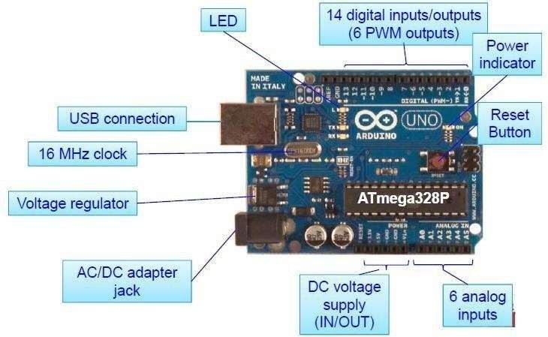
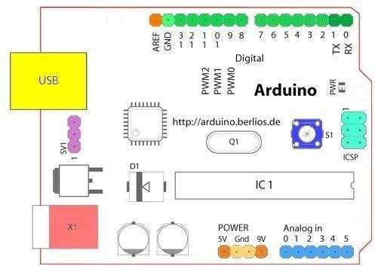

Fig.1: Standard Arduino UNO

- Digital I/O Pins 0 –13;
- 0 & 1 (Dark Green) can be Serial In/Out – Tx/Rx; These pins cannot be used for digital I/O (digitalRead and digitalWrite) if we are also using serial communication (e.g. Serial.begin)
- Analog In Pins 0-5 (light blue)
- ISP– InSystemProgrammingalso called In-circuit serialprogramming(ICSP)
- External Power Supply In (9-12VDC) – X1 (pink)
- USB (used for uploading sketches to the board and for serial communication between the board and the computer; can be used to power the board)
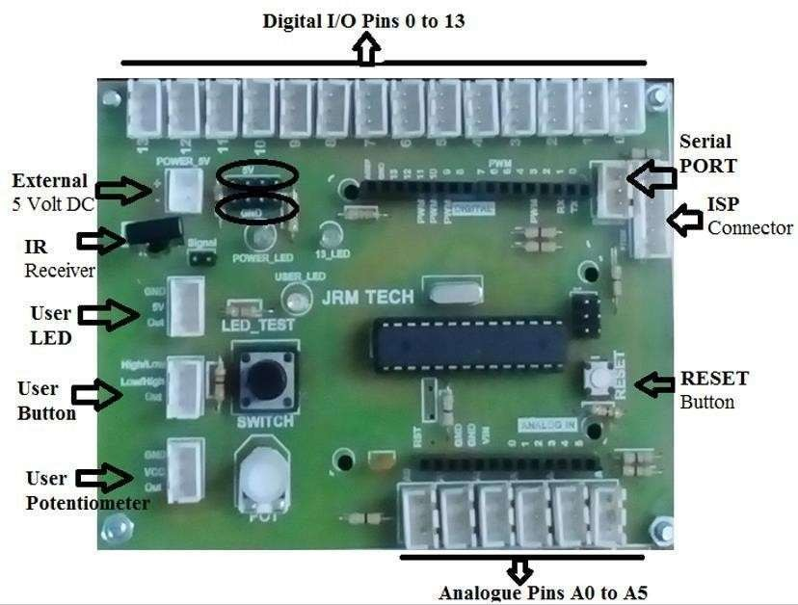

Fig.2: DIY – JRM Arduino Uno

- One Onboard LED 13th Pin
- One User LED
- One User Button-Switch
- One Potentiometer
- IR Receiver

INSTALLATION PROCEDURE:

- Download & install the Arduino environment (IDE)
- Connect the board to your computer via the USB cable
- If needed, install the drivers
- Launch the Arduino IDE
- Select your board
- Select your serial port
- Open the blink example (for checking)
- Upload the program

Task #1
Blink the onboard LED in Uno

Program:

void setup()
{
pinMode(13, OUTPUT);
// initialize digital pin 13 as an output.
}

void loop()
{
digitalWrite(13, HIGH); delay(1000); digitalWrite(13, LOW);
delay(1000);
}

OUTPUT:

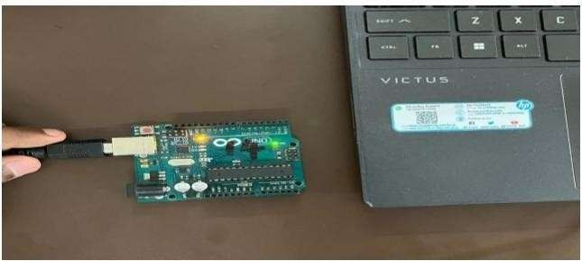

Task #2:

Blink the user LED in Uno using the port D8 Program:
void setup()
{
pinMode(8, OUTPUT);
}
void loop()
{
digitalWrite(8,HIGH);
delay(1000); // Wait for 1000 millisecond(s) digitalWrite(8,LOW);
delay(1000); // Wait for 1000 millisecond(s)
}

OUTPUT:
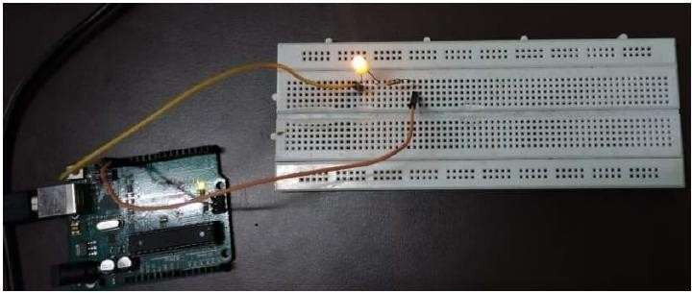

Task #3:

Blink the Two user LED in Uno using the port D8,D9 Program:
void setup() { pinMode(8, OUTPUT); pinMode(9, OUTPUT);
}
void loop() { digitalWrite(8, HIGH); digitalWrite(9, LOW); delay(1000); digitalWrite(8, LOW); digitalWrite(9, HIGH); delay(1000);
}

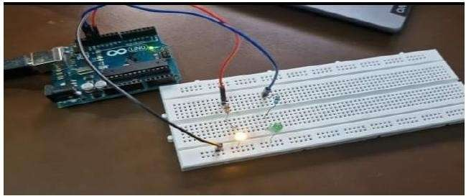
OUTPUT:

RESULT:

Thus, the installation of Arduino Uno is done and working process is verified with the help of “blinking LED programs”.
Ex No: 02

Date:

INTERFACING SENSORS AND ACTUATORS ARDUINO

AIM:

To interface sensors and actuators with Arduino to acquire data from the environment and control devices, enabling the implementation of automated systems.
COMPONENTS REQUIRED:

SI.No. | Components Name | Quantity
1 | Arduino Uno | 1
2 | USB 2.0 – Mini B Type | 1
3 | Power Adaptor – 12 V | 1
4 | Temperature Sensor (LM35) | 1
5 | DC Motor/Servo Motor | 1
6 | Buzzer | 1
7 | PC with Windows OS -32/64 bit | 1
8 | Resistor (220Ω Each) | 2
9 | Jumper Wires | As Required
10 | Bread Board | 1

THEORY:

SENSOR:

In simple words, a sensor is a device that “listens” to the physical environment and tells you what happens. Each sensor is able to listen to a specific input, that can be light, heat, motion, moisture, pressure, or any one of a great variety of other environmental phenomena.

ACTUATOR:

In the strict meaning, actuator is a device that converts energy in movement. It could be a valve or a motor. I consider an actuator anything that can convert electric energy in an output, for example a display, a led, a loudspeaker.
DIGITAL AND ANALOG:

- Information may be represented and transmitted both in analogic or digital format. The difference between them is that in analogic technology information is represented by amplitude variations, while in digital it’s represented in binary format.
- Arduino can do analog and digital inputs, and only digital outputs. The sensors themselves usually are analog, but most of times they have a small circuit that translates values into digital format. In some cases, you’ll find both connectors on the same device.
- So, analog pins on Arduino are always input. Digital pins can be input or output, your code will tell which pin should be choose.

Task #1

To interface a temperature sensor (e.g., LM35) with Arduino Program:
const int sensorPin = A0; void setup() { Serial.begin(9600);
Serial.println("Temperature Sensor Interface Starting...");
}
void loop() {
int sensorValue = analogRead(sensorPin); float voltage = sensorValue * (5.0 / 1023.0); float temperature = voltage * 100.0; Serial.print("Temperature: "); Serial.print(temperature);
Serial.println(" °C"); delay(1000);
}

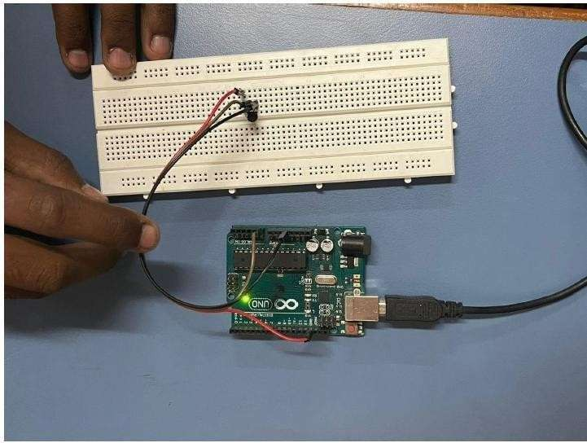
OUTPUT:

Task #2

Interfacing LM35 Temperature Sensor and Buzzer with Arduino to Implement a Threshold-based Alert System
Program:

const int tempSensorPin = A0; const int buzzerPin = 9;
const float thresholdTemp = 40.0; void setup() { pinMode(tempSensorPin, INPUT); pinMode(buzzerPin, OUTPUT); Serial.begin(9600);
}
void loop() {
int analogValue = analogRead(tempSensorPin); float voltage = (analogValue / 1023.0) * 5.0; float temperature = voltage * 100.0; Serial.print("Temperature: "); Serial.print(temperature);
Serial.println(" °C");
if (temperature > thresholdTemp) { digitalWrite(buzzerPin, HIGH);
} else {
digitalWrite(buzzerPin, LOW);
}

delay(1000);
}

OUTPUT:

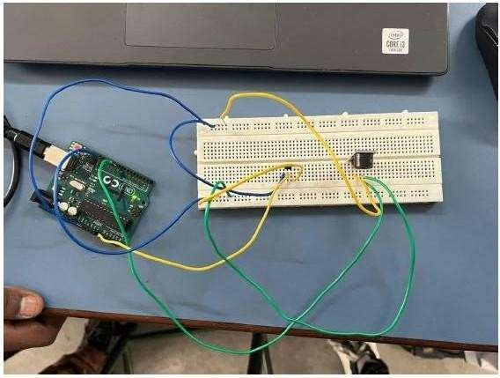

Task #3

Interfacing Stepper Moror / Servo Motor with Arduino Program:
void setup() {

pinMode (8,OUTPUT); pinMode (9,OUTPUT); pinMode (10,OUTPUT); pinMode (11,OUTPUT);
}

void loop() { digitalWrite(8,HIGH); delay(5); digitalWrite(8,LOW); delay(5); digitalWrite(9,HIGH); delay(5); digitalWrite(9,LOW); delay(5); digitalWrite(10,HIGH); delay(5); digitalWrite(10,LOW);

delay(5); digitalWrite(11,HIGH); delay(5); digitalWrite(11,LOW); delay(5);
}

OUTPUT:

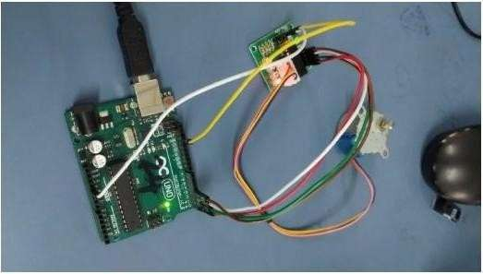

RESULT:

Thus, the interface of sensors and actuators with Arduino to acquire data from the environment and control devices, enabling the implementation of automated systems have been verified.

Ex No: 03

Date:

INTRODUCTION TO RASBERRY PI PLATFORM AND PYTHON
PROGRAMMING

AIM:

To study the installation procedure of Raspberry Pi OS, set up the Wokwi simulation, and verify its successful setup.
COMPONENTS REQUIRED:

SI.No. | Components Name | Quantity
1 | Wokwi Simulation Platform | 1
2 | Raspberry Pi Pico (Virtual) | 1
3 | LED | 2
4 | Resistor (220Ω each) | 2
5 | Jumper Wires | 4
6 | Breadboard (Virtual) | 1

THEORY:

CONFIGURATION OF RASPBERRY PI ON WOKWI
Wokwi

An online simulator for embedded systems development.
Raspberry Pi Pico (Virtual):

Simulated microcontroller for testing Python code.

GPIO Pins (General Purpose Input/Output)

Used to connect virtual components.

Code Editor

Built-in Python editor to run MicroPython code.

INSTALLATION PROCEDURE:

Access Wokwi Simulation :
- Open Wokwi in a web browser.
  - Select 'New Project' and choose 'Raspberry Pi Pico'.
Adding Components:
  - Drag and drop an LED, resistors, and jumper wires onto the simulation canvas.
  - Connect the components as per the circuit diagram.
Writing and Running the Code:
  - Open the code editor in Wokwi.
  - Write the Python program for blinking LEDs.
  - Click the 'Run' button to execute the program

PIN CONFIGURATION
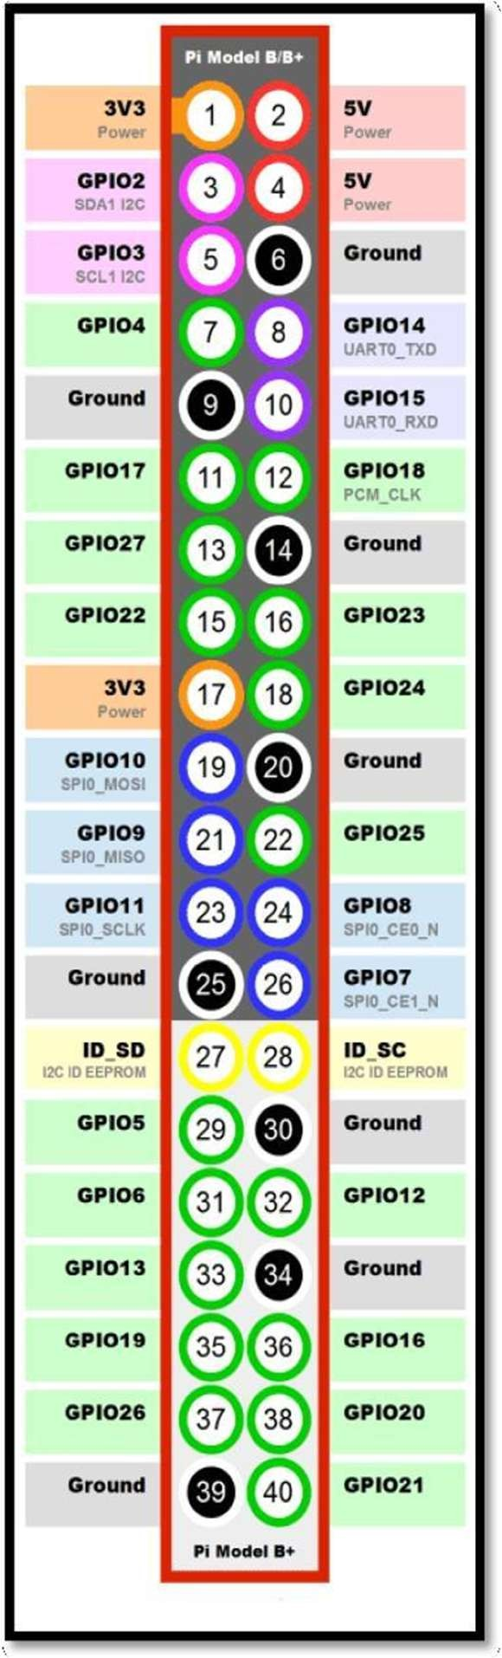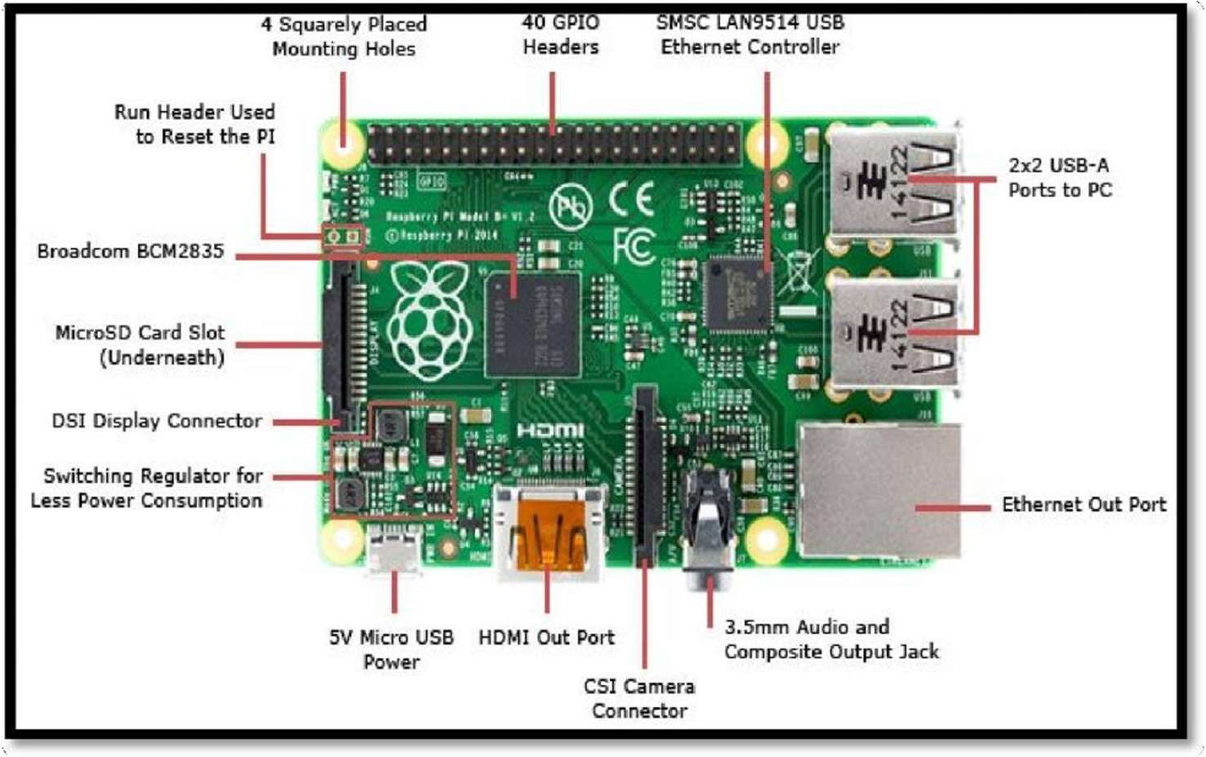

Asshown in above figure, there are 40output pins for the PI. But all 40 pin out cannot be programmed to our use. Only 26 GPIO pins can be programmed. These pins go from GPIO2 to GPIO27. These 26 GPIO pins can be programmed as per need. Some of these pins also perform some special functions. With special GPIO put aside, we have 17 GPIO remaining (Light green Cirl).

Task #1

Blink an LED Using Wokwi Simulation Program:
import machine import utime

LED_PIN = machine.Pin(17, machine.Pin.OUT)

while True:
LED_PIN.value(1) # Turn LED ON utime.sleep(1) # Wait for 1 second LED_PIN.value(0) # Turn LED OFF utime.sleep(1) # Wait for 1 second

OUTPUT:

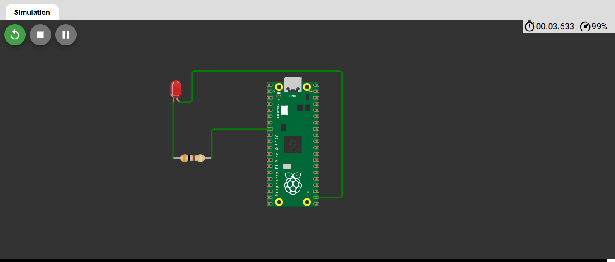
Task #2

Blink Two LEDs Alternately Using Wokwi Program:
import machine import utime

LED1 = machine.Pin(17, machine.Pin.OUT)
LED2 = machine.Pin(18, machine.Pin.OUT)

while True: LED1.value(1) LED2.value(0) utime.sleep(1) LED1.value(0) LED2.value(1) utime.sleep(1)

OUTPUT:

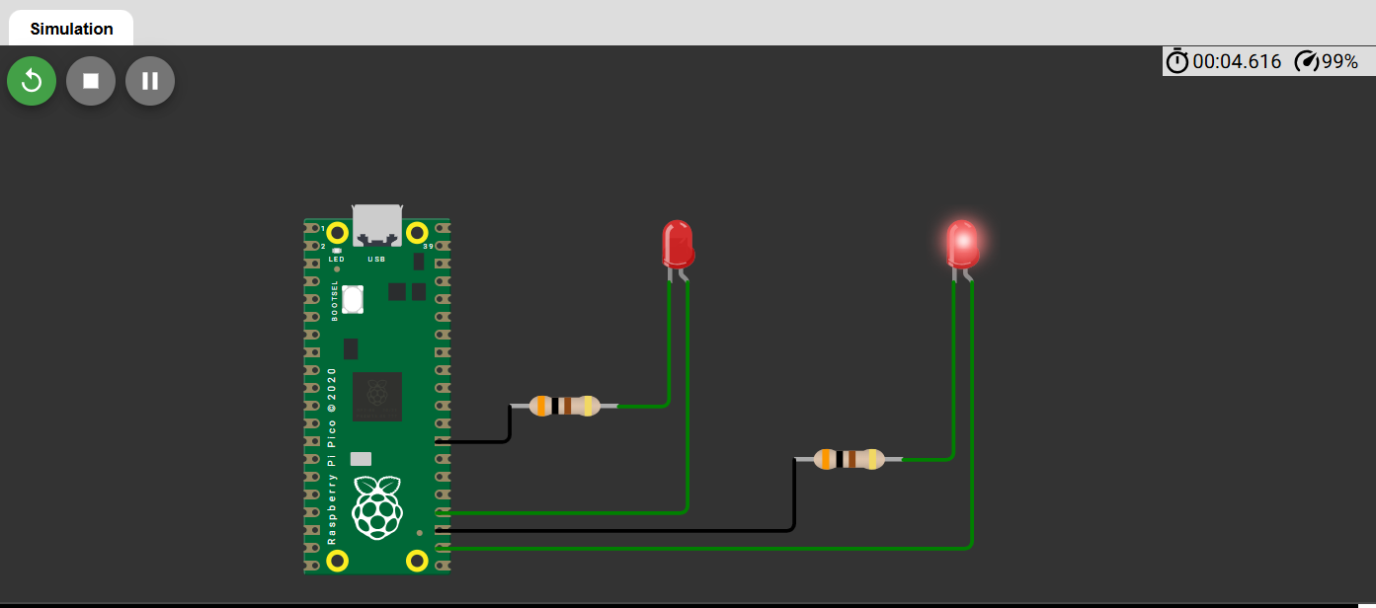
Task #3

Control an LED using a push button on the Wokwi simulator using a Raspberry Pi Pico
Program:

from machine import Pin import time
led = Pin(15, Pin.OUT) # LED connected to GPIO15
button = Pin(14, Pin.IN, Pin.PULL_UP)
while True:

if button.value() == 0: # Button is pressed (active LOW) led.value(1) # Turn LED ON
else:

led.value(0) # Turn LED OFF

time.sleep(0.1) # Small delay for button debounce

OUTPUT:
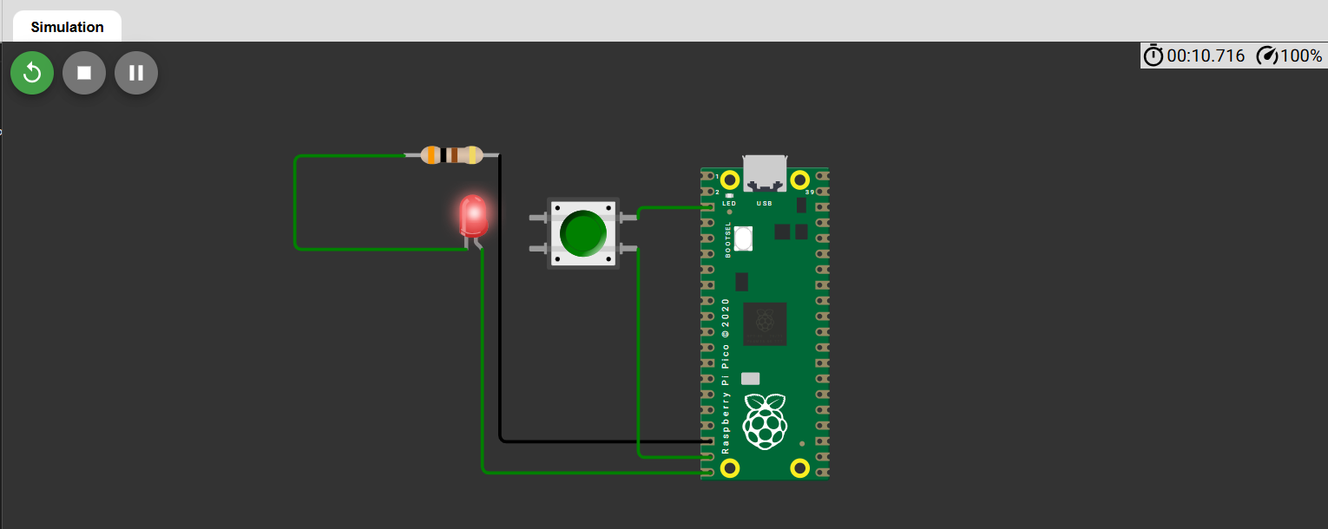

RESULT:

Thus, the Raspberry Pi platform was successfully simulated in Wokwi, and the working process was verified using MicroPython programs to blink an LED.

Ex No: 04

Date:

INTERFACING SENSORS AND ACTUATORS TO RASPBERRY PI

AIM:

To interface various sensors and actuators with Raspberry Pi using the Wokwi simulation platform and verify their functionality using Python programming.
COMPONENTS REQUIRED:

SI.No. | Components Name | Quantity
1 | Wokwi Simulation Platform | 1
2 | Raspberry Pi Pico (Virtual) | 1
3 | LED | 2
4 | Resistor (220Ω each) | 2
5 | Jumper Wires | 4
6 | Breadboard (Virtual) | 1
7 | Ultrasonic Sensor (HC-SR04) | 1
8 | Servo Motor | 1
9 | DHT11 Temperature Sensor | 1

THEORY:

CONFIGURATION OF RASPBERRY PI ON WOKWI
Wokwi is an online simulator for embedded systems development that allows testing Micro Python code with virtual components.

GPIO Pins (General Purpose Input/Output)

Used to interface sensors and actuators like LEDs, buttons, servo motors, and ultrasonic sensors.

INSTALLATION PROCEDURE:

Access Wokwi Simulation :
- Open Wokwi in a web browser.
  - Select 'New Project' and choose 'Raspberry Pi Pico'.
Adding Components:
  - Drag and drop the required sensors, actuators, and necessary circuit elements
onto the simulation canvas.
  - Connect the components as per the circuit diagram.
Writing and Running the Code:
  - Open the code editor in Wokwi.
  - Write the Python program to interface the selected sensor or actuator.

  - Click the 'Run' button to execute the program

PIN CONFIGURATION

Asshown in above figure, there are 40output pins for the PI. But all 40 pin out cannot be programmed to our use. Only 26 GPIO pins can be programmed. These pins go from GPIO2 to GPIO27. These 26 GPIO pins can be programmed as per need. Some of these pins also perform some special functions. With special GPIO put aside, we have 17 GPIO remaining (Light green Cirl).

Task #1

Blink an LED Using Wokwi Simulation Program:
import machine import utime
LED_PIN = machine.Pin(17, machine.Pin.OUT) while True:
LED_PIN.value(1) # Turn LED ON utime.sleep(1) # Wait for 1 second LED_PIN.value(0) # Turn LED OFF utime.sleep(1) # Wait for 1 second
OUTPUT:

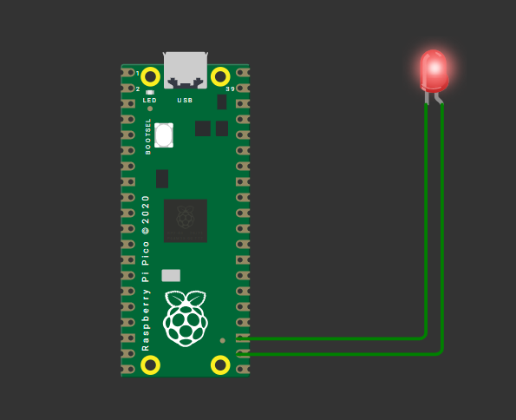

Task #2

Interface an Ultrasonic Sensor (HC-SR04) to Measure Distance Program:
import machine import utime
trigger = machine.Pin(2, machine.Pin.OUT) echo = machine.Pin(3, machine.Pin.IN) def get_distance():
trigger.value(1) utime.sleep_us(10) trigger.value(0)
while echo.value() == 0: signaloff = utime.ticks_us()
while echo.value() == 1: signalon = utime.ticks_us()
timepassed = signalon - signaloff distance = (timepassed * 0.0343) / 2 return distance
while True:

print("Distance:", get_distance(), "cm") utime.sleep(1)

OUTPUT:
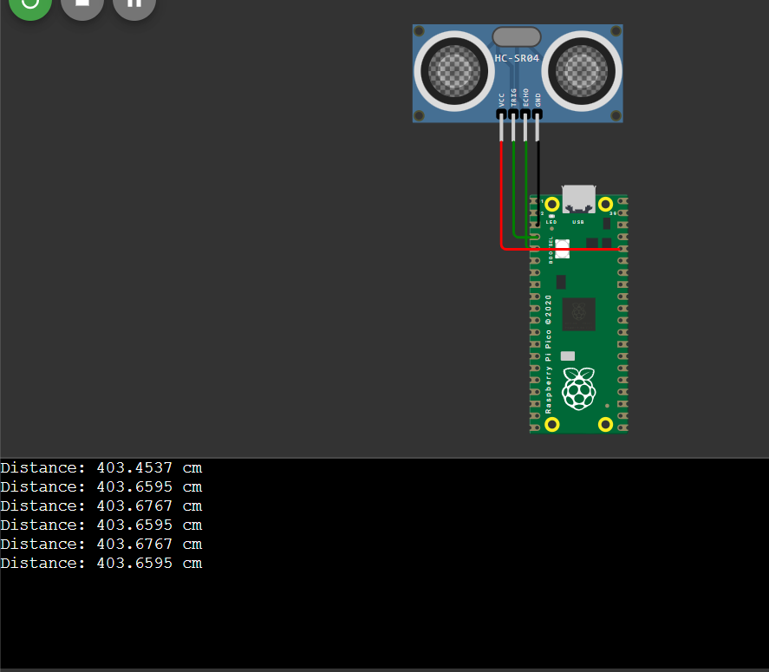

Task #3

Control a Servo Motor Using Raspberry Pi Pico Program:
import machine import utime
servo = machine.PWM(machine.Pin(15)) servo.freq(50)
def set_angle(angle):

duty = int((angle / 180) * 1023) servo.duty_u16(duty) utime.sleep(1)
while True: set_angle(0) utime.sleep(1) set_angle(90) utime.sleep(1) set_angle(180) utime.sleep(1)

OUTPUT:

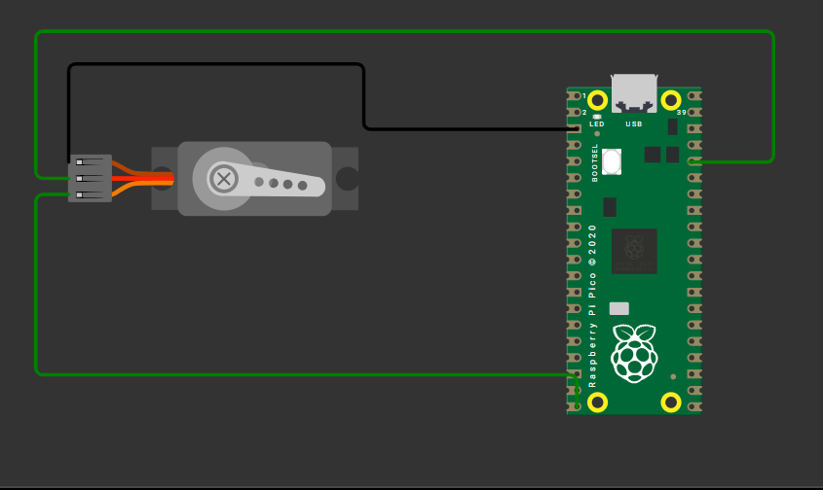

Task # 4

Read Temperature and Humidity Using DHT11 Sensor Program
import machine import dht import utime
dht_sensor = dht.DHT11(machine.Pin(16)) while True:
dht_sensor.measure()

temp = dht_sensor.temperature() humidity = dht_sensor.humidity() print("Temperature:", temp, "C") print("Humidity:", humidity, "%") utime.sleep(2)

OUTPUT:

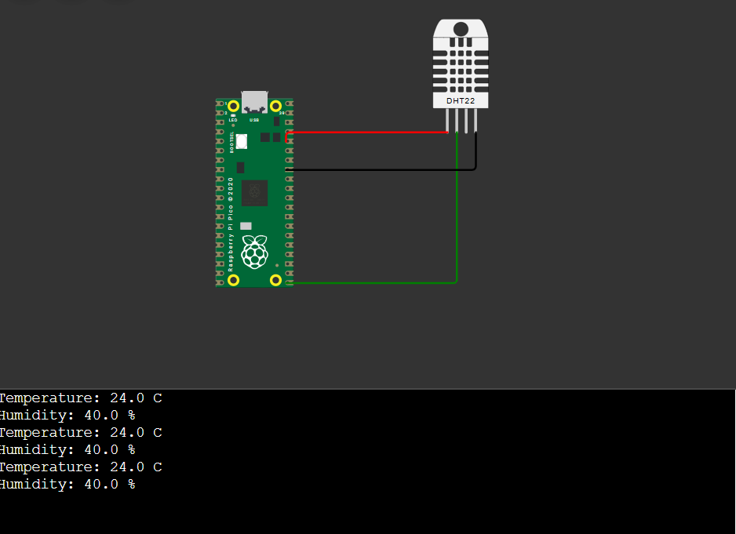

RESULT:

Thus, various sensors and actuators were successfully interfaced with the Raspberry Pi Pico using the Wokwi simulator, and their operation was verified using Python programs.

Ex No: 05

Date:

SETUP A CLOUD PLATFORM TO LOG THE DATA

AIM:

To set up a cloud platform for logging data collected from sensors interfaced with Raspberry Pi using the Wokwi simulation platform and verify the data storage and retrieval process.
COMPONENTS REQUIRED:

SI.No. | Components Name | Quantity
1 | Wokwi Simulation Platform | 1
2 | Raspberry Pi Pico (Virtual) | 1
3 | DHT11 Temperature Sensor | 1
4 | Wi-Fi Module (ESP8266 – Virtual) | 1
5 | Cloud Platform (Thing speak) | 1
6 | Jumper Wires | 4

THEORY:

Cloud platforms allow remote data logging and monitoring of sensor readings from IoT devices. In this experiment, we use Thingspeak (or Firebase) to log data from a temperature and humidity sensor connected to a Raspberry Pi Pico via Wokwi simulation. The Wi-Fi module (ESP8266) transmits the data to the clou.

INSTALLATION PROCEDURE:

Access Wokwi Simulation :
- Open Wokwi in a web browser.
- Select 'New Project' and choose 'Raspberry Pi Pico'.
Adding Components:
- Drag and drop the DHT11 sensor, ESP8266 Wi-Fi module, and necessary connections onto the simulation canvas.
- Connect the components as per the circuit diagram

Setting Up Cloud Logging (Thingspeak/Firebase):

- Create an account on Thingspeak (https://thingspeak.com/) or Firebase (https://firebase.google.com/).
- Set up a new data stream to receive sensor values.
- Obtain API keys for authentication.

Writing and Running the Code:

- Open the code editor in Wokwi.
- Write the Python program to interface the DHT11 sensor, connect to Wi-Fi, and send data to the cloud.
- Click the 'Run' button to execute the program

PIN CONFIGURATION

- DHT11 Sensor → GPIO16 (Data)

- ESP8266 Wi-Fi Module → UART (GPIO0 & GPIO1 for TX/RX)

Program:

import network import urequests import utime import machine import dht
# Wi-Fi Credentials

SSID = "Your_WiFi_SSID"

PASSWORD = "Your_WiFi_Password" API_KEY = "Your_Thingspeak_API_Key" # Setup Sensor
dht_sensor = dht.DHT11(machine.Pin(16)) # Connect to Wi-Fi
def connect_wifi():

wlan = network.WLAN(network.STA_IF) wlan.active(True)
wlan.connect(SSID, PASSWORD) while not wlan.isconnected():

pass

print("Connected to Wi-Fi") # Send Data to Thingspeak def send_data():
dht_sensor.measure()

temp = dht_sensor.temperature()

humidity = dht_sensor.humidity()

url = f"https://api.thingspeak.com/update?api_key={API_KEY}& field1={temp}&field2={humidity}"
response = urequests.get(url) response.close()
print(f"Data Sent: Temp={temp}C, Humidity={humidity}%") # Main Loop
connect_wifi() while True:
send_data()

utime.sleep(15) # Send data every 15 seconds

SCREENSHORT:
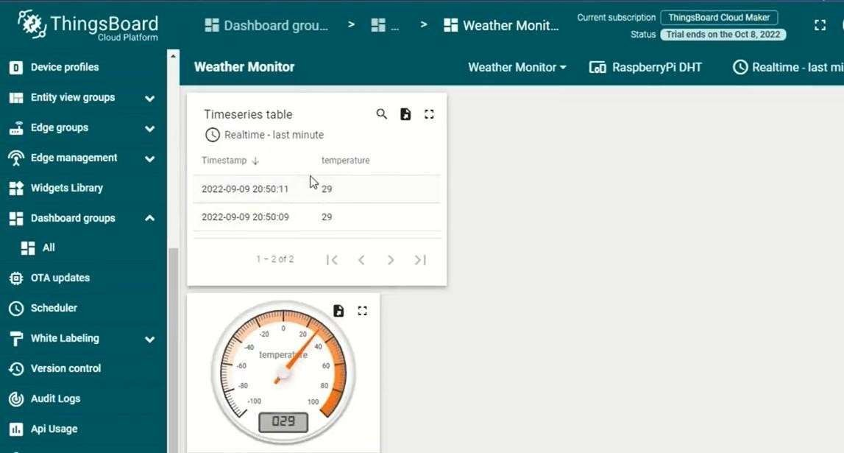

RESULT:

Thus, a cloud platform was successfully set up for logging sensor data using the Wokwi simulator, and data storage and retrieval were verified using Python programming.

Ex No: 06

Date:
LOG DATA USING RASPBERRY PI AND UPLOAD TO THE CLOUD PLATFORM AIM:
To log real-time sensor data using Raspberry Pi and upload it to a cloud platform for remote monitoring and analysis.
COMPONENTS REQUIRED:

SI.No. | Components Name | Quantity
1 | Raspberry Pi | 1
2 | DHT11 Temperature Sensor | 1
3 | Wi-Fi Module (Built-in or USB) | 1
4 | Cloud Platform (ThingSpeak/Firebase) | 1
5 | Breadboard | 1
6 | Jumper Wires | 4

THEORY:

Cloud platforms enable IoT devices to send sensor data for real-time storage and remote access. This experiment demonstrates how to log temperature and humidity data using a DHT11 sensor connected to a Raspberry Pi and upload it to ThingSpeak for visualization.
STEPS FOR BUILDING RASPBERRY PI DATA LOGGER ON CLOUD STEP 1: SIGNUP FOR THINGSPEAK
For creating your channel on ThingSpeak you first need to sign up on ThingSpeak.
In case if you already have account on ThingSpeak just sign in using your id and password.

Click on signup if you don’t have account and if you already have account click on sign in.
After clicking on signup fill your details.
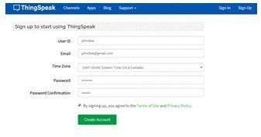

After this verify your E-mail id and click on continue.

STEP 2: CREATE A CHANNEL FOR YOUR DATA
Once you Sign in after your account verification, create a new channel by clicking “New Channel” button.
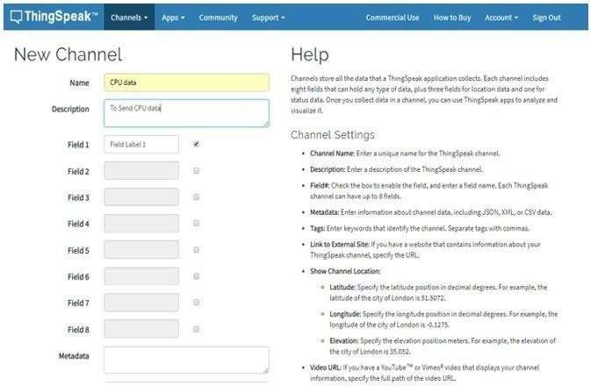

After clicking on “New Channel”, enter the Name and Description of the data you want to upload on this channel.
For example, I am sending my CPU data (temperature), so I named it as CPU data.

Now enter the name of your data (like Temperature or pressure) in Field1. If you want to use more than one Field you can check the box next to Field option and enter the name and description of your data.
After this click on save channel button to save your details.

STEP 3: GETTING API KEY IN THINGSPEAK

To send data to ThingSpeak, we need a unique API key, which we will use later in our python code to upload our CPU data to ThingSpeak Website.
Click on “API Keys” button to get your unique API key for uploading your CPU data.
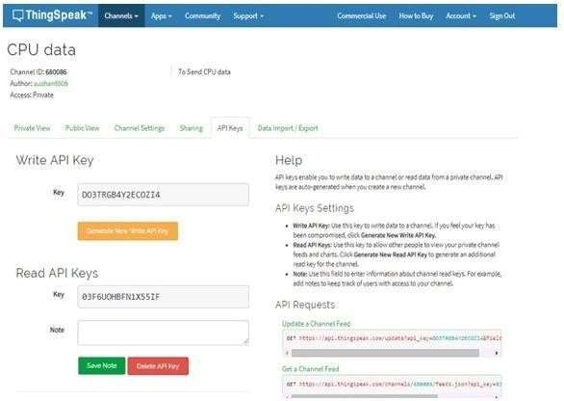

Now copy your “Write API Key”. We will use this API key in our code.

STEP 4: PYTHON CODE FOR RASPBERRY PI
Complete code is given at the end of this tutorial, just make a file with any name and .py extension and copy-paste the code and save the file. Don’t forget to replace the API key with yours. You can run the python file any time using below command:
python /path/filename.py

Assuming you already installed python in Raspberry pi using this command

sudo apt-get install python

CASE 1:

If you are using monitor screen then just use the given code. Now install all libraries
sudo

apt-get

- After installing libraries run your python code (python
/path/filename.py)
- If the code runs properly, you will see some CPU temperature values as shown below image
- If there are any errors uploading the data, you will receive “connection failed” message

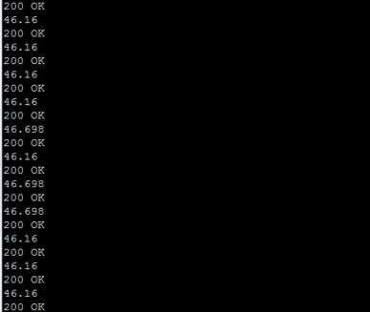

CASE 2:

If you are using “Putty” then you should follow these commands First update your pi using
sudo apt-get update

After this make a file cpu.py using
nano cpu.py

After creating this file copy your code to this file and save it using CTRL + X and then ‘y’ and enter.

After this install all libraries using
sudo apt-get install httplib

sudo apt-get install urllib

After installing libraries run your python code using:
python cpu.py

If the code runs properly you will see some CPU temperature values as shown in above image.
STEP 6: CHECK THINGSPEAK SITE FOR DATA LOGGING

After completing these steps open your channel and you will see the CPU temperature data is updating into ThingSpeak website.
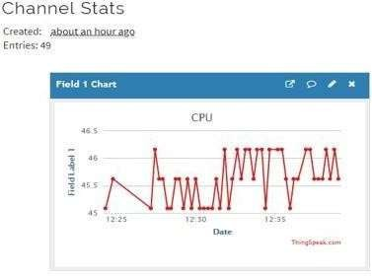

- Like this you can send any sensor data connected with Raspberry pi to the ThingSpeak Cloud. In next article we will connect LM35

temperature sensor with Raspberry Pi and send the temperature data to ThingSpeak, which can be monitored from anywhere.
- Complete Python code for this Raspberry Pi Cloud Server is given below. Code is easy and self-explanatory to understand.
CODE:

import time import board
import adafruit_dht import requests
# Setup DHT Sensor

dht_sensor = adafruit_dht.DHT11(board.D4) THINGSPEAK_API_KEY = "YOUR_API_KEY"
THINGSPEAK_URL = "https://api.thingspeak.com/update" while True:
try:

temp = dht_sensor.temperature humidity = dht_sensor.humidity
print(f"Temperature: {temp}C, Humidity: {humidity}%") # Send Data to ThingSpeak
params = {"api_key": THINGSPEAK_API_KEY, "field1": temp, "field2": humidity}
requests.get(THINGSPEAK_URL, params=params)

except RuntimeError as e: print("Error reading sensor: ", e)
time.sleep(15) # Log every 15 seconds

OUTPUT:

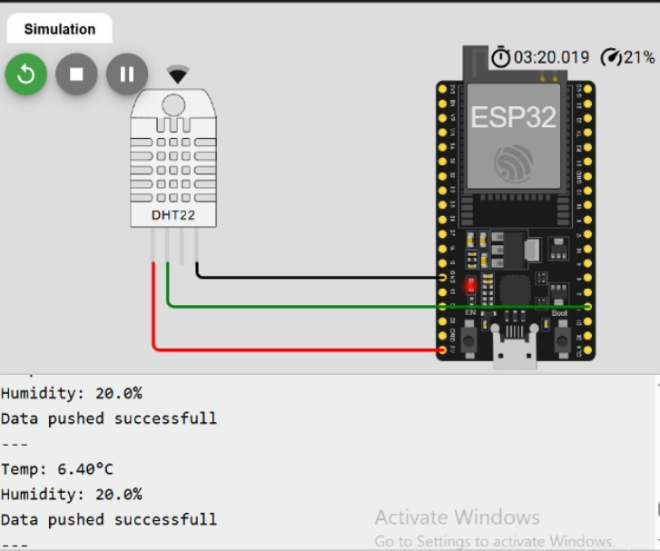

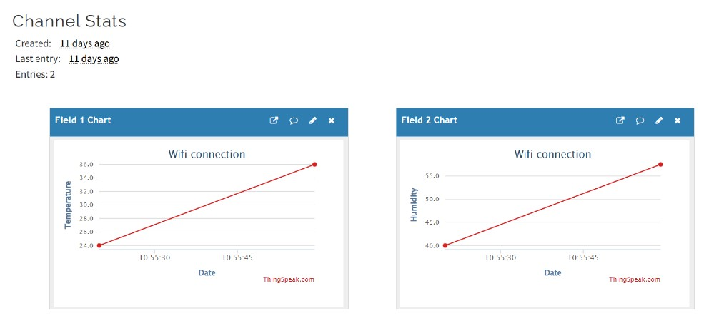

RESULT:

Thus, a cloud platform was successfully set up for logging sensor data using the Wokwi simulator, and data storage and retrieval were verified using Python programming.
Ex No: 07 A)

Date:

DESIGN AN IOT BASED SYSTEM - HC - 05

AIM:

To design and implement an IoT-based system using Raspberry Pi and an HC-05 Bluetooth module to control an LED remotely.
COMPONENTS REQUIRED:

SI.No. | Components Name | Quantity
1 | Raspberry Pi | 1
2 | HC-05 Bluetooth Module | 1
3 | LED | 1
4 | Resistor (220Ω) | 1
5 | Breadboard | 1
6 | Jumper Wires | 4

THEORY:

The HC-05 Bluetooth module enables wireless communication between Raspberry Pi and external devices like smartphones or microcontrollers. In this experiment, the Raspberry Pi receives commands via Bluetooth and controls an LED accordingly.
INSTALLATION PROCEDURE: STEP 1: SET UP THE RASPBERRY PI
- Install Raspberry Pi OS and ensure Bluetooth is enabled.
- Update the system:

sudo apt update && sudo apt upgrade -y

- Install Bluetooth libraries:

sudo apt-get install bluetooth bluez python3-bluetooth

STEP 2: CONNECT HC-05 BLUETOOTH MODULE AND LED

HC-05 WIRING:

VCC → 5V GND → GND
TX → RX (GPIO15) RX → TX (GPIO14)
LED WIRING:

Anode (+) → GPIO17 (through a 220Ω resistor) Cathode (-) → GND
STEP 3: CONFIGURE HC-05 ON RASPBERRY PI

- Enable the serial interface on Raspberry Pi:

sudo raspi-config

Go to Interfacing Options → Serial

Disable login shell access and enable the serial port.

- Restart the Raspberry Pi.

STEP 4: WRITE PYTHON CODE TO CONTROL LED VIA BLUETOOTH

- Open a new Python script: nano bluetooth_led.py

CODE:

import RPi.GPIO as GPIO import serial
# Setup LED Pin LED_PIN = 17
GPIO.setmode(GPIO.BCM) GPIO.setup(LED_PIN, GPIO.OUT)
# Setup Bluetooth Communication

bt_serial = serial.Serial("/dev/serial0", baudrate=9600, timeout=1) print("Waiting for Bluetooth command...")
while True:

data = bt_serial.readline().decode('utf-8').strip() if data:
print(f"Received: {data}")

if data == "ON": GPIO.output(LED_PIN, GPIO.HIGH)
print("LED Turned ON")

elif data == "OFF": GPIO.output(LED_PIN, GPIO.LOW)
print("LED Turned OFF")

- Save and exit

STEP 5: RUN THE SCRIPT
python3 bluetooth_led.py

STEP 6: SEND COMMANDS FROM A BLUETOOTH TERMINAL APP

- Pair the HC-05 module with a smartphone using a Bluetooth terminal app.
- Send "ON" to turn the LED ON.
- Send "OFF" to turn the LED OFF.

SCREENSHOTS:
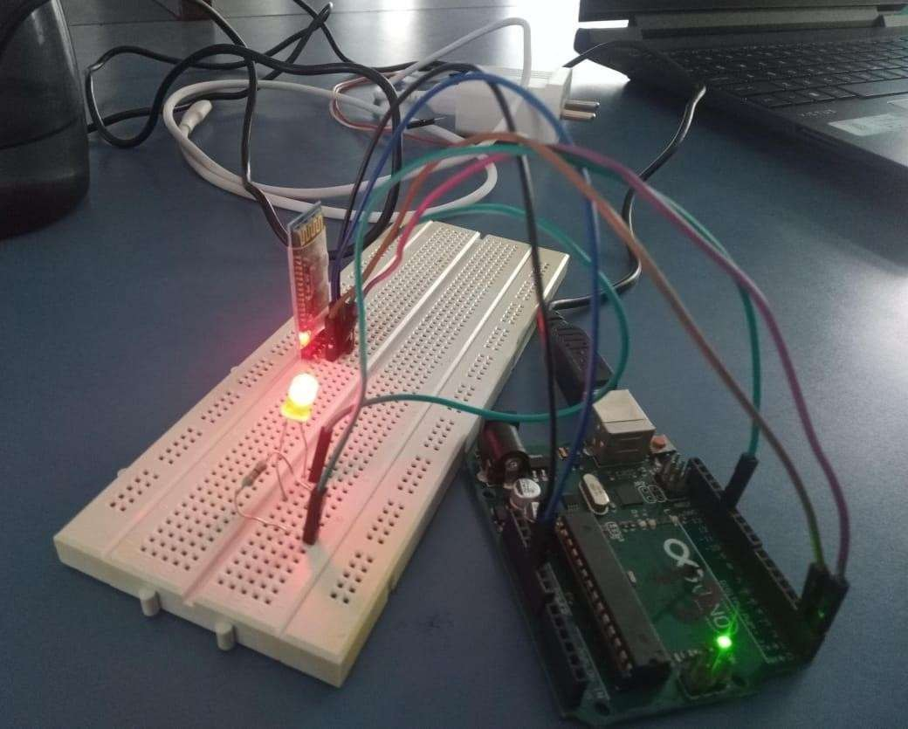
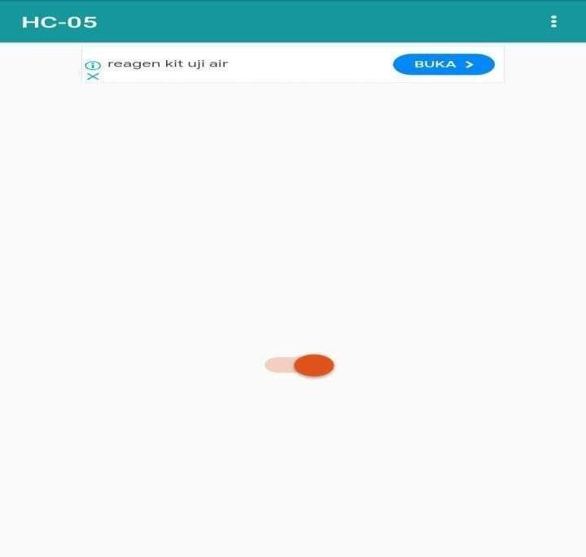

RESULT:
Thus, an IoT-based system using an HC-05 Bluetooth module was successfully designed to control an LED remotely.

07 B) DESIGN AN IoT-BASED SYSTEM USING SOIL MOISTURE SENSOR AIM:
To design and implement an IoT-based system using an Arduino and Soil Moisture Sensor to monitor soil moisture levels and control an LED indicator remotely.
COMPONENTS REQUIRED:

SI.No. | Components Name | Quantity
1 | Arduino Uno | 1
2 | Soil Moisture Sensor | 1
3 | LED | 1
4 | Resistor (220Ω) | 1
5 | Breadboard | 1
6 | Jumper Wires | 5

THEORY:

Soil moisture sensors measure the volumetric water content of soil, providing data for automated irrigation systems. In this experiment, the Arduino Uno reads sensor data, processes it, and turns ON/OFF an LED based on the soil moisture level.

INSTALLATION PROCEDURE:

STEP 1: CONNECT SOIL MOISTURE SENSOR AND LED

SOIL MOISTURE SENSOR WIRING:

VCC → 5V GND → GND
A0 → A0 (Analog pin for moisture reading)

LED WIRING:

Anode (+) → Pin 8 (through a 220Ω resistor) Cathode (-) → GND
STEP 2: WRITE ARDUINO CODE TO MONITOR SOIL MOISTURE

- Open the Arduino IDE.

- Create a new sketch and copy the following code: #define sensorPin A0
#define sensorPower 7

#define LED_PIN 8 void setup() {
pinMode(sensorPower, OUTPUT); pinMode(LED_PIN, OUTPUT);
Serial.begin(9600);

}
void loop() { Serial.print("Analog output : "); int val = readSensor(); Serial.println(val);
if (val > 1000) {

Serial.println("Low moisture detected! Water the plants"); digitalWrite(LED_PIN, HIGH);

} else {

digitalWrite(LED_PIN, LOW);

}

delay(1000);

}

int readSensor() { digitalWrite(sensorPower, HIGH); delay(10);
int val = analogRead(sensorPin); digitalWrite(sensorPower, LOW); return val;
}

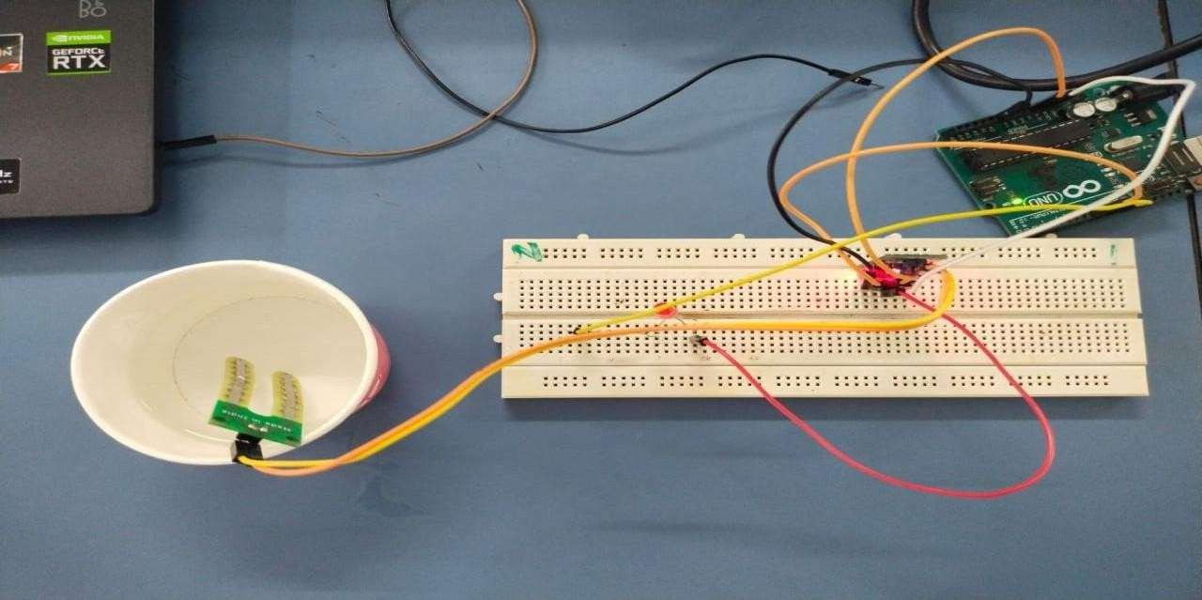
OUTPUT:

RESULT

Thus, an IoT-based system using an Arduino and Soil Moisture Sensor was successfully designed to monitor soil conditions and indicate the need for irrigation.

Ex No: 08

Date:

DEVELOP THE VEHICLE PARKING SYSTEM IN SMART CITIES USING IOE AIM:
To design and implement an IoT-based Vehicle Parking System using an Ultrasonic Sensor and Arduino to detect the presence of vehicles and indicate availability using an LED.
COMPONENTS REQUIRED:

SI.No. | Components Name | Quantity
1 | Arduino Uno | 1
2 | Ultrasonic Sensor (HC-SR04) | 1
3 | LED | 1
4 | Resistor (220Ω) | 1
5 | Breadboard | 1
6 | Jumper Wires | 5

THEORY:

An IoT-based Vehicle Parking System uses an Ultrasonic Sensor to detect whether a parking space is occupied or vacant. The distance measured by the sensor helps determine the presence of a vehicle, and an LED is used as an indicator for parking availability.

INSTALLATION PROCEDURE:

STEP 1: CONNECT THE ULTRASONIC SENSOR AND LED

ULTRASONIC SENSOR WIRING:

Ultrasonic Sensor Pin Arduino Pin

VCC 5V

GND GND
TRIG 9
ECHO 10
LED WIRING:

LED Pin Arduino Pin

Anode (+) 6 (through a 220Ω resistor)

Cathode (-) GND

STEP 2: WRITE ARDUINO CODE TO MEASURE DISTANCE

#define TRIG_PIN 9

#define ECHO_PIN 10

#define LED_PIN 6 void setup() {
pinMode(TRIG_PIN, OUTPUT); pinMode(ECHO_PIN, INPUT); pinMode(LED_PIN, OUTPUT);
Serial.begin(9600);

}

void loop() { long duration; int distance;
// Send 10us pulse to trigger pin digitalWrite(TRIG_PIN, LOW); delayMicroseconds(2); digitalWrite(TRIG_PIN, HIGH); delayMicroseconds(10); digitalWrite(TRIG_PIN, LOW);

// Read echo pin and calculate distance duration = pulseIn(ECHO_PIN, HIGH);
distance = duration * 0.034 / 2; // Convert to cm Serial.print("Distance: ");
Serial.print(distance); Serial.println(" cm");
// If object is closer than 10 cm, turn on LED if (distance > 0 && distance < 10) {
digitalWrite(LED_PIN, HIGH);

} else {

digitalWrite(LED_PIN, LOW);

}

delay(500); // Wait before next measurement

}

SCREENSHOTS:
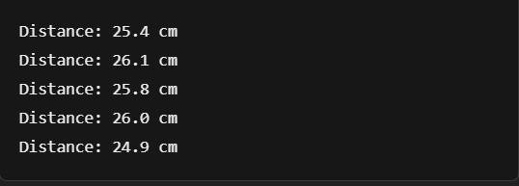

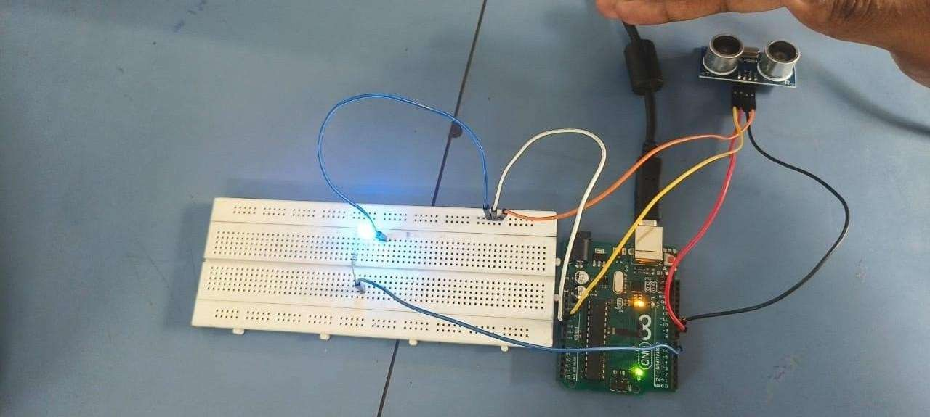

RESULT:

Thus, an IoT-based system using an ultrasonic sensor and an LED was successfully designed and implemented to detect proximity and trigger an LED accordingly.

Ex No: 09

Date:

DEVELOP AN LOE-ENABLED HEALTHCARE SYSTEM FOR REMOTE AND NEAR PATIENT MONITORING
AIM:

To develop an Internet of Everything (IoE)-enabled healthcare system using Wokwi to monitor heart rate, temperature, and humidity remotely using a Pulse Rate Sensor and DHT22.
COMPONENTS REQUIRED:

SI.No. | Components Name | Quantity
1 | ESP32 | 1
2 | DHT22 Sensor | 1
3 | Pulse Rate Sensor | 1
4 | Resistor (220Ω) | 1
5 | Breadboard | 1
6 | Jumper Wires | 6

THEORY:

IoE in healthcare enables real-time remote monitoring of vital parameters, improving patient care and response time. The ESP32 microcontroller reads data from a DHT22 temperature-humidity sensor and a pulse rate sensor, then transmits the values to an MQTT broker for real-time monitoring.

INSTALLATION PROCEDURE:

STEP 1: SET UP WOKWI SIMULATION ENVIRONMENT

- Open Wokwi in a web browser.

- Select "New Project" and choose "ESP32" as the microcontroller.

- Add the required components: DHT22 sensor and Pulse Rate Sensor.

- Connect the components as per the wiring table.

STEP 2: CONNECT THE SENSORS

DHT22 SENSOR WIRING:

DHT22 Pin ESP32 Pin

VCC 3.3V

GND GND
Data 12
PULSE RATE SENSOR WIRING:

Pulse Sensor Pin ESP32 Pin

VCC 3.3V

GND GND
Signal 35

STEP 3: WRITE ESP32 CODE FOR DATA ACQUISITION AND MQTT PUBLISHING

#include <Wire.h> #include <WiFi.h> #include <DHT.h> #include <PubSubClient.h> #include <Arduino.h> #define DHT_PIN 12
// Define PULSE_PIN

#define PULSE_PIN 35

#define MQTT_SERVER "broker.emqx.io" #define MQTT_PORT 1883
const char *ssid = "Wokwi-GUEST"; const char *password = "";
#define MQTT_TOPIC_HR "/heartRate" #define MQTT_TOPIC_TEMP "/tempValue" #define MQTT_TOPIC_HUM "/humValue" WiFiClient espClient;
PubSubClient client(espClient); DHT dht(DHT_PIN, DHT22);
void setup() { Wire.begin(23, 22);

Serial.begin(115200); Serial.println("Hello, ESP32!"); connectToWiFi();
client.setServer(MQTT_SERVER, MQTT_PORT); dht.begin();
}

void loop() {

if (!client.connected()) { reconnect();
}

float temperature = dht.readTemperature(); float humidity = dht.readHumidity();
// Read pulseValue from PULSE_PIN

int16_t pulseValue = analogRead(PULSE_PIN);

// Convert pulseValue to voltage

float voltage = pulseValue * (5 / 4095.0);

// calculate heartRate from volatge int heartRate = (voltage / 3.3) * 675;
// Print HeartRate Serial.print("Heart Rate"); Serial.print(heartRate);

Serial.print(" Temp: "); Serial.print(temperature); Serial.print(" Humidity: "); Serial.println(humidity) delay(100);
client.publish(MQTT_TOPIC_HR, String(heartRate).c_str()); client.publish(MQTT_TOPIC_TEMP, String(temperature).c_str()); client.publish(MQTT_TOPIC_HUM, String(humidity).c_str()); Serial.print("Sent mtqq data");
delay(10);

}

void connectToWiFi() { WiFi.begin(ssid, password);
while (WiFi.status() != WL_CONNECTED) { delay(1000);
Serial.println("Connecting to WiFi...");

}

Serial.println("Connected to WiFi");

}

void reconnect() {

while (!client.connected()) {

if (client.connect("esp32_neopixel_controller")) { Serial.println("Connected to MQTT");
} else {

Serial.print("Failed, rc="); Serial.print(client.state()); Serial.println(" Retrying in 5 seconds..."); delay(5000);
}

}

}

OUTPUT:

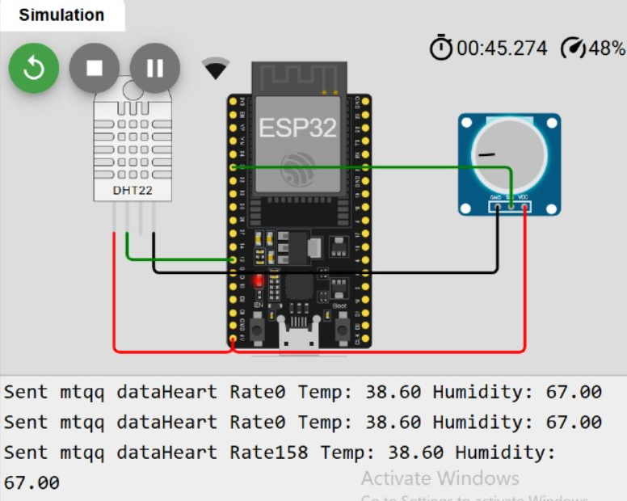

RESULT:

Thus, an IoE-enabled healthcare system was successfully developed using Wokwi to monitor heart rate, temperature, and humidity remotely.

Ex No: 10

Date:

DEVELOP AN IOE APPLICATION TO HANDLE DATA ACQUISITION WITH INTEGRATION OF THE OUTPUT DEVICES
AIM:

To develop an Internet of Everything (IoE) application using Wokwi to monitor temperature, humidity, and gas concentration, and activate an alert system using an LED and buzzer.
COMPONENTS REQUIRED:

SI.No. | Components Name | Quantity
1 | Arduino Uno | 1
2 | DHT11 Sensor | 1
3 | MQ-2 Gas Sensor | 1
4 | Buzzer | 1
5 | LED | 1
6 | Breadboard | 1
7 | Jumper Wires | 6

THEORY:

IoE applications integrate data acquisition with output devices for monitoring and automation. This project utilizes an Arduino Uno to read temperature and humidity data from a DHT11 sensor and detect gas concentration using an MQ-2 gas sensor. If the temperature exceeds 40°C or the gas level surpasses a threshold, a buzzer and LED alert the user.

INSTALLATION PROCEDURE:

STEP 1: SET UP WOKWI SIMULATION ENVIRONMENT

- Open Wokwi in a web browser.

- Select "New Project" and choose "Arduino Uno" as the microcontroller.

- Add the required components: DHT11 sensor, MQ-2 Gas Sensor, Buzzer, and LED.

- Connect the components as per the wiring table.

STEP 2: CONNECT THE SENSORS AND OUTPUT DEVICES

DHT11 SENSOR WIRING:

DHT11 Pin Arduino Pin

VCC 5V

GND GND
Data 2
MQ-2 GAS SENSOR WIRING:

MQ-2 Pin Arduino Pin

VCC 5V

GND GND

A0 A0

BUZZER AND LED WIRING:

Device Pin
Buzzer 5
LED 6

STEP 3: WRITE ARDUINO CODE FOR DATA ACQUISITION AND ALERT SYSTEM
#include <DHT.h>

#define DHTPIN 2 // DHT sensor connected to pin 2 #define DHTTYPE DHT11 // Change to DHT22 if using DHT22 DHT dht(DHTPIN, DHTTYPE);
#define GAS_SENSOR A0 // MQ-2 Gas Sensor connected to A0 #define BUZZER 5 // Buzzer on pin 5
#define LED 6 // LED on pin 6 void setup() {
Serial.begin(9600); dht.begin();
pinMode(GAS_SENSOR, INPUT); pinMode(BUZZER, OUTPUT); pinMode(LED, OUTPUT);
}

void loop() {

// Read Temperature and Humidity

float temperature = dht.readTemperature(); float humidity = dht.readHumidity();
// Read Gas Sensor Value

int gasValue = analogRead(GAS_SENSOR);

// Display Sensor Data in Serial Monitor

Serial.print("Temp: "); Serial.print(temperature); Serial.print("°C "); Serial.print("Humidity: "); Serial.print(humidity); Serial.print("% "); Serial.print("Gas: "); Serial.println(gasValue);
// Condition: Temperature > 40°C or Gas Level > 300

if (temperature > 40 || gasValue > 300) { digitalWrite(BUZZER, HIGH); digitalWrite(LED, HIGH);
Serial.println(".ı ALERT! Unsafe conditions detected!");

} else {

digitalWrite(BUZZER, LOW);

digitalWrite(LED, LOW);

}

delay(2000); // Wait for next reading

}

STEP 4: RUN THE SIMULATION

- Click the "Start Simulation" button in Wokwi.

- Open the Serial Monitor to observe temperature, humidity, and gas readings.

- Verify that the LED and buzzer activate when conditions exceed safe limits.

SCREENSHOTS:
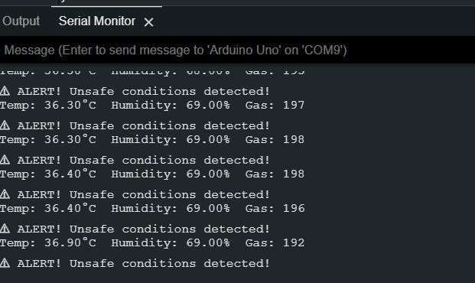

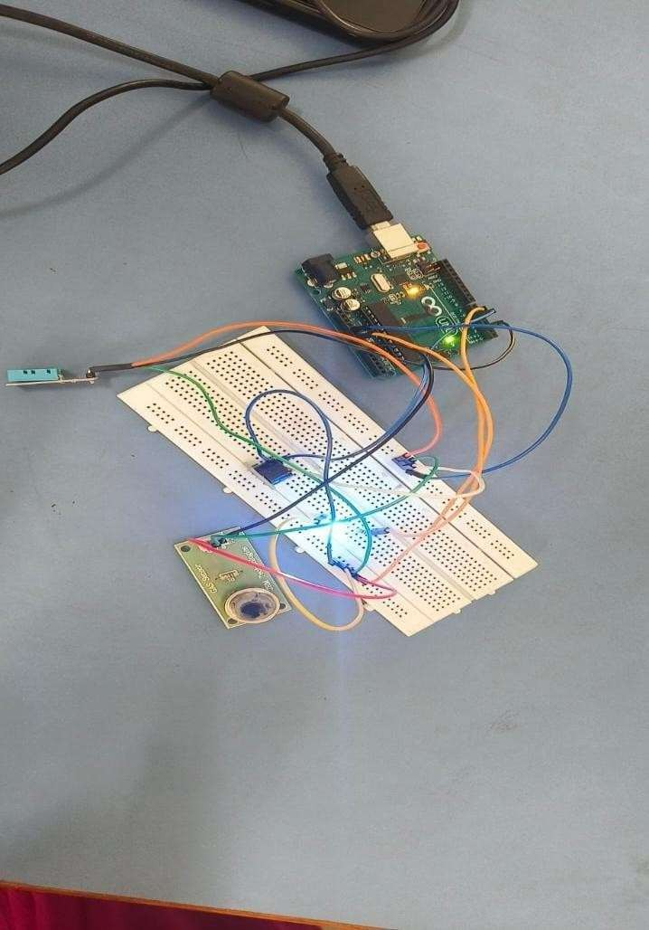

RESULT:

Thus, an IoE application was successfully developed using Wokwi to monitor temperature, humidity, and gas concentration, with an integrated alert system using an LED and buzzer.

